UFTC Thin Client Troubleshooting

This manual is designed to help tech support diagnose issues with UFTC based thin client.

# Boot and login

During boot the thin clients display a boot log instead of a logo, if they freeze up during boot you can ask the user for a photo. Boot failures are most likely to be either hardware or update related and cannot be fixed remotely.

If the thinclient has a bootup slowdown where it stalls for on the same line in the log for 10+ seconds before the login screen is present this is because wifi was enabled on a machine without a wifi adapter. For the fastest boot times it is recommended that you only deploy a wifi configuration to machines that need it.

Upon successful boot the thin client will display a login screen to the user.

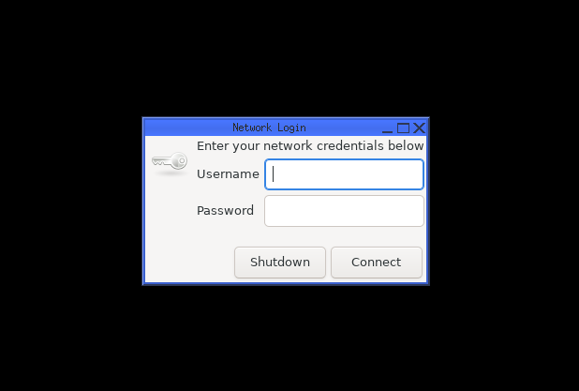

For any server related errors after logging in the user will be shown a message with appropriate troubleshooting steps.

If this login screen fails to display users can right click on the black desktop if they see a mouse for troubleshooting options (If they have not seen a bootup log and do not see the mouse check if the thin client and monitor are both turned on).

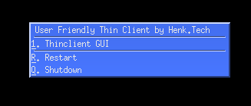

During testing the main cause of login screen failure was during the first boot when the machines rename themselves. This can be fixed by using the restart option. Subsequent bootups do not have this issue as the device is already renamed.

If the following screen is shown instead of the login screen the thin client does not contain a valid configuration and can be configured in the next screen. If a user has filled in incorrect configuration details including a wrong admin password it is recommended to reinstall the device.

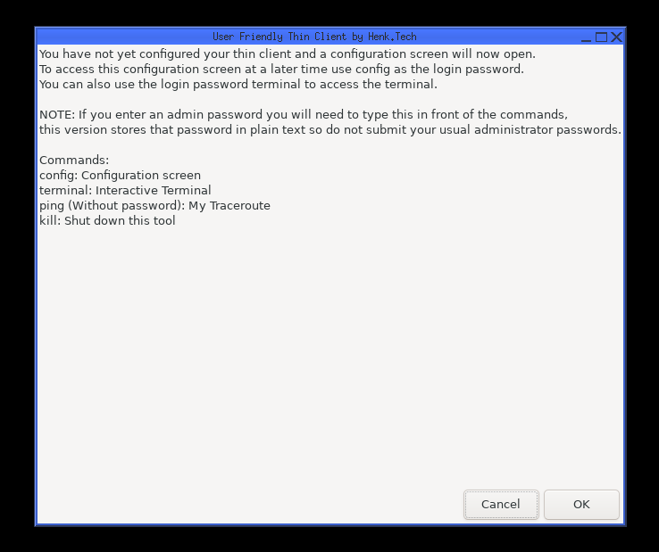

# Diagnosing connectivity issues

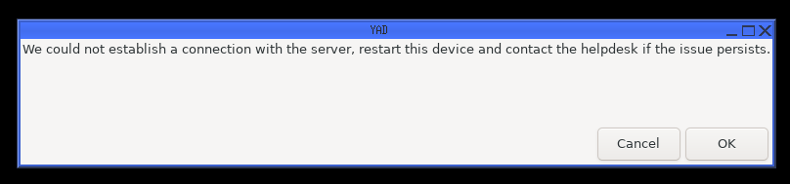

If users experience connectivity issues the ping command can be used to find out where the problem is. Ask if the user can type the word ping as the password.

If nothing happens after the ping command and the login dialog is immediately shown again the device did not connect to the network. For physical connections check the network cable. For wireless connections ask the user to restart the device, if this does not work check if the wireless access points in the area are functional. If this is a new thin client it is possible that it was incorrectly installed, it is currently not possible to apply wifi information remotely as a suitable configuration must be placed on the boot partition. For security reasons running machine have no access to this location.

If the device is successfully connected you will see a screen that contains the connectivity information. Ask the user to send a photo.

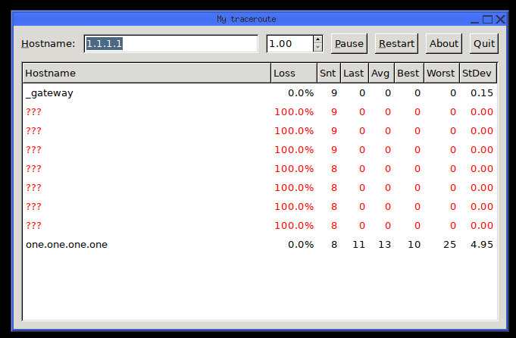

Here you can see at which point the connection fails or has loss, for loss to count all hostnames below the first one showing loss should have similar loss. This example had no loss because the last hostname is loss free.

# On-SITE sERVICING

To use some commands on-site you will need to put the admin password and command in the password dialog. For example if your password is p and you wish to change the RDP server you use pconfig as the login password.

The admin password can be found at : *[Location of the password within your company (If you see this please update this documentation)]*

## Configuration

To access the configuration screen use config as the password prefixed by the admin password.

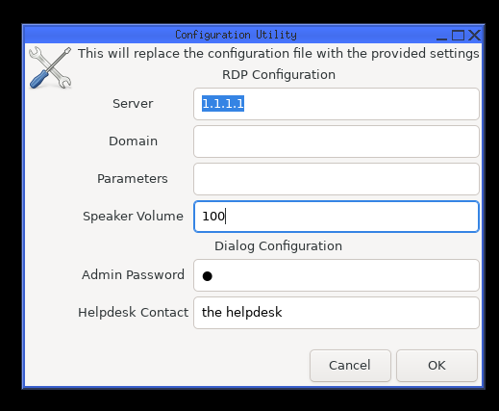

In this screen we can change all the settings related to remote desktop.  
If the domain is set correctly users do not have to type a domain to login.

Speaker volume determines the maximum/default volume of the system, inside remote desktop the slider will not change. On some devices 100 can be to quiet, going over 100 is possible but increase this in small steps.

For a full list of parameters type xfreerdp in the terminal or look up the xfreerdp manual online. Here are some useful ones:

**-drives** , disable passing through usb drives / cd’s

**/network**: this can be set to modem, broadband, broadband-low, broadband-high, wan or lan. If not specified the device will automatically try to pick the best mode. Use this setting if the automatic mode is unreliable.

**/g** Gateway Hostname

**/gu** *[<domain>\]<user> or <user>[@<domain>]* Gateway username

**/gp** Gateway password

**/gd** Gateway domain

**/usb:auto** redirect usb devices

**/scale:** this can be set to 140 or 180 to increase the size of the objects in the remote session.

## Terminal access

If you need access to the terminal use terminal as the password prefixed by the admin password.

Inside the terminal you can use nano session.log to see a detailed log of the last session. This also contains the raw errors in case an unknown error happened that did not get shown to the user.

(Automatic) updates can be installed with auto-maintenance, but this should be avoided outside of test systems. If automatic updates are enabled but need to be disabled you can do this with auto-maintenance disable.

Set-hostname allows you to manually define the hostname, for this to remain intact the dynamic_hostname file must be deleted.